Game Design Document

Fill up the following document

1. Write the title of your project.

The zombie Shooter

1. What is the goal of the game?

The goal of the game is to shoot all the zombies dead or they will eat the shooter alive.

1. Write a brief story of your game.

A skilled shooter is lost in the Dead City and he is fighting for his life by killing all the zombies which come in his way with his gun. If the shooter is able to shoot the zombies dead then he survives else if the zombies capture the shooter he loses one life out of the three lives he has in total!

1. Which are the playing characters of this game?

* Playing characters are the ones who respond to the user based on the input from the user.
* Cars, monkeys, dinos, wizards, etc., are the playing characters in the game.

|  |  |  |
| --- | --- | --- |
| Number | Character Name | What can this character do? |
| 1 | Shooter | Kill the zombies to save his life |
| 2 | Zombies | Eat the shooter if he is not able to save himself |
| 3 |  |  |
| 4 |  |  |
| 5 |  |  |
| 6 |  |  |
| 7 |  |  |
| 8 |  |  |

1. Which are the Non-Playing Characters of this game?

* Non-Playing characters are the ones that don't have an action or behavior when the user interacts with the game.
* Hurdles, stones, bananas, coins, etc., are non-playing characters in the game.

|  |  |  |
| --- | --- | --- |
| Number | Character Name | What can this character do? |
| 1 | Gun | Release the bullets |
| 2 | Bullets | Shoot the zombies dead |
| 3 |  |  |
| 4 |  |  |
| 5 |  |  |
| 6 |  |  |
| 7 |  |  |
| 8 |  |  |

Draw your imagination of this game. What does this game look like?

* Draw the game either on your computer or on paper.
* Add images of the game scenes to show each of the playing and non-playing characters at least once.

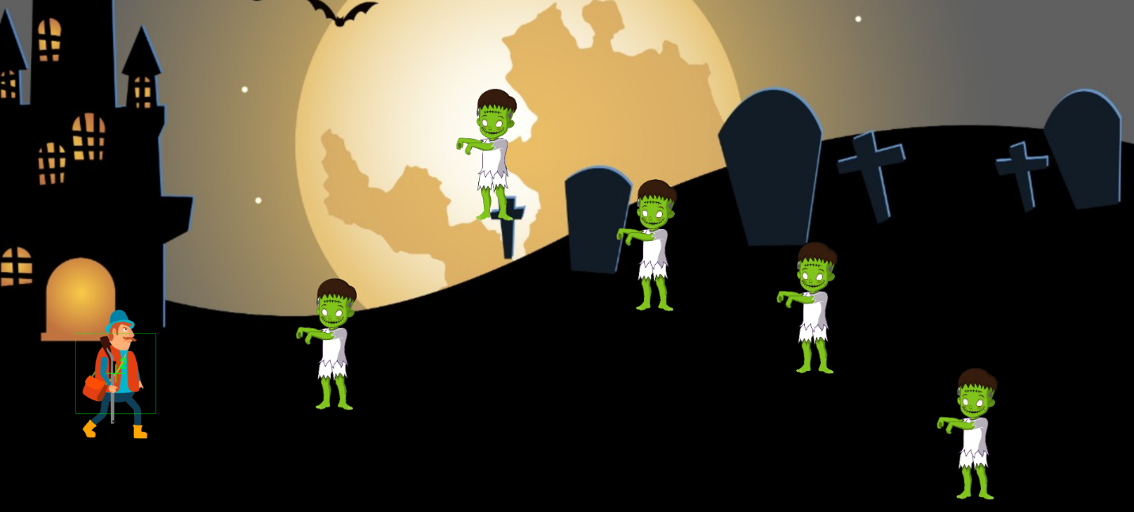

How do you plan to make your game engaging?

I plan to make my game engaging by increasing the difficulty level by spawning more zombies at a faster rate so as to make it difficult for the shooter to kill them and save himself.